Launch Jenkins and explore creating projects and users.

Here, we are going to download the Jenkins package from Jenkins website

Link: [**http://localhost:8080**](http://localhost:8080)

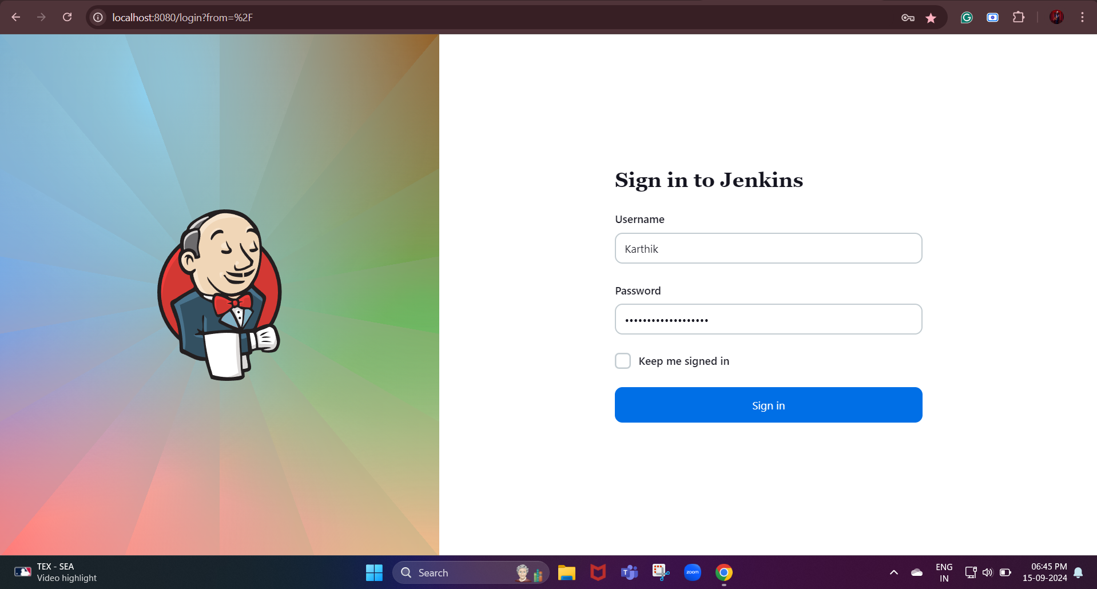

**Next, we are going to create projects in Jenkins:**

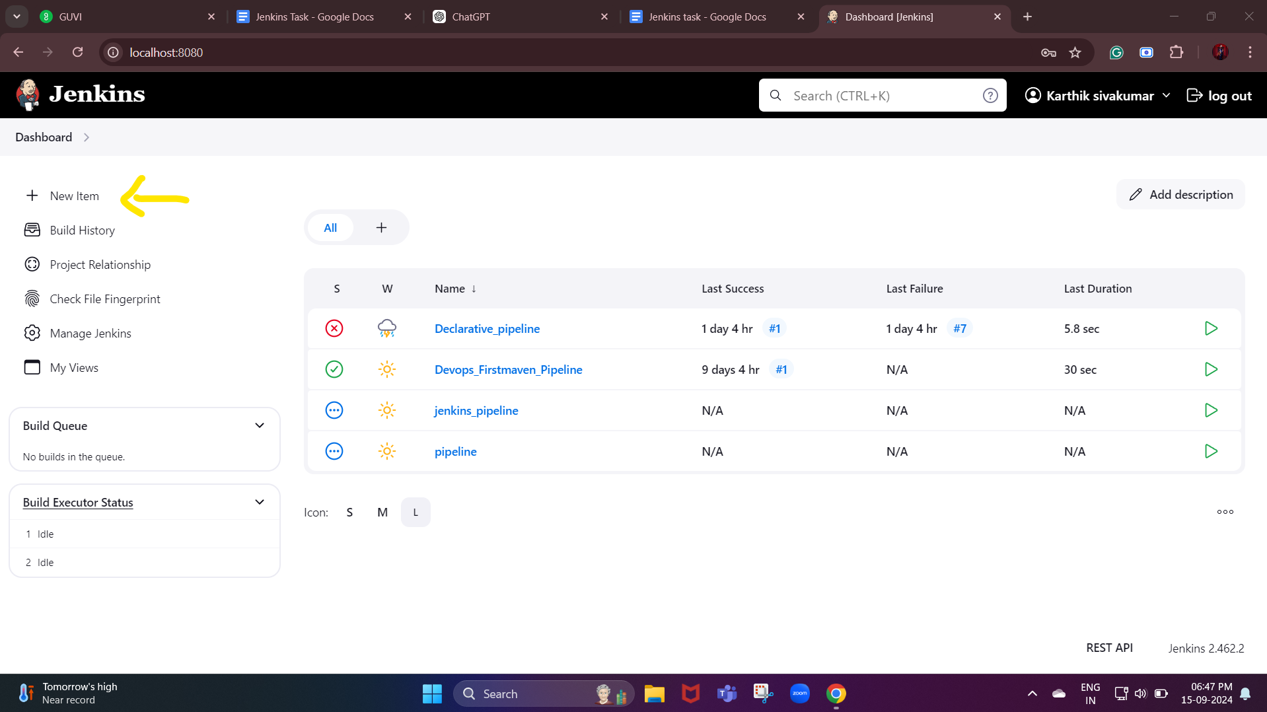

**We need to click on the new item to create the new project**

**Next, we need to select the type of job that consists of a freestyle job, pipeline, multi-configuration project, etc.**

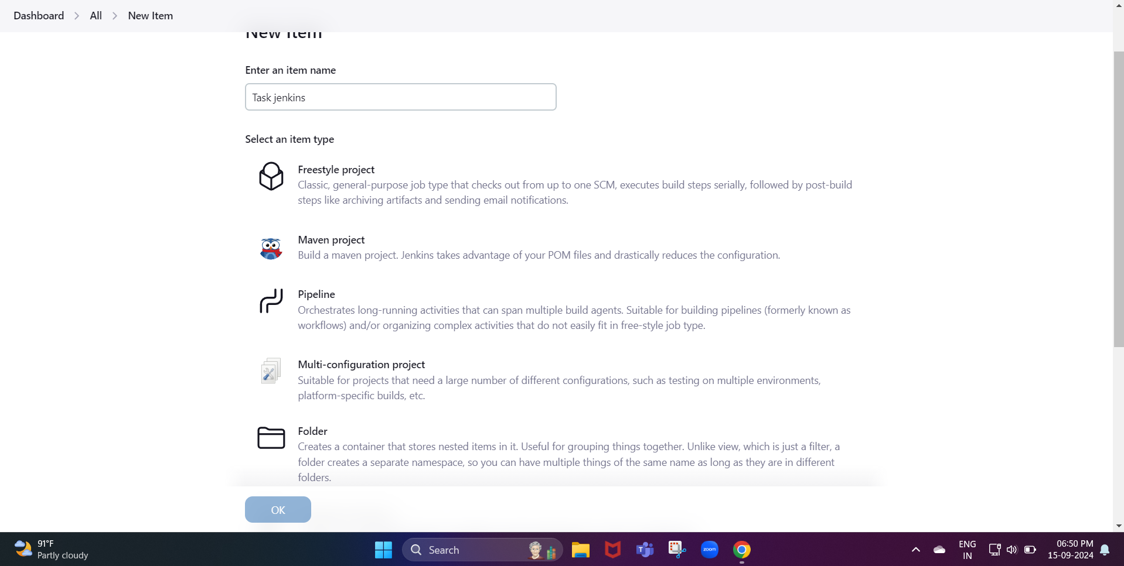

**Configure the job by setting parameters such as:**

* **Source code management (Git, SVN, etc.).**
* **Build triggers (manual, scheduled, or triggered by code changes).**
* **Build steps (e.g., running a shell script, building code, running tests).**
* **Post-build actions (e.g., archiving artifacts, sending notifications).**

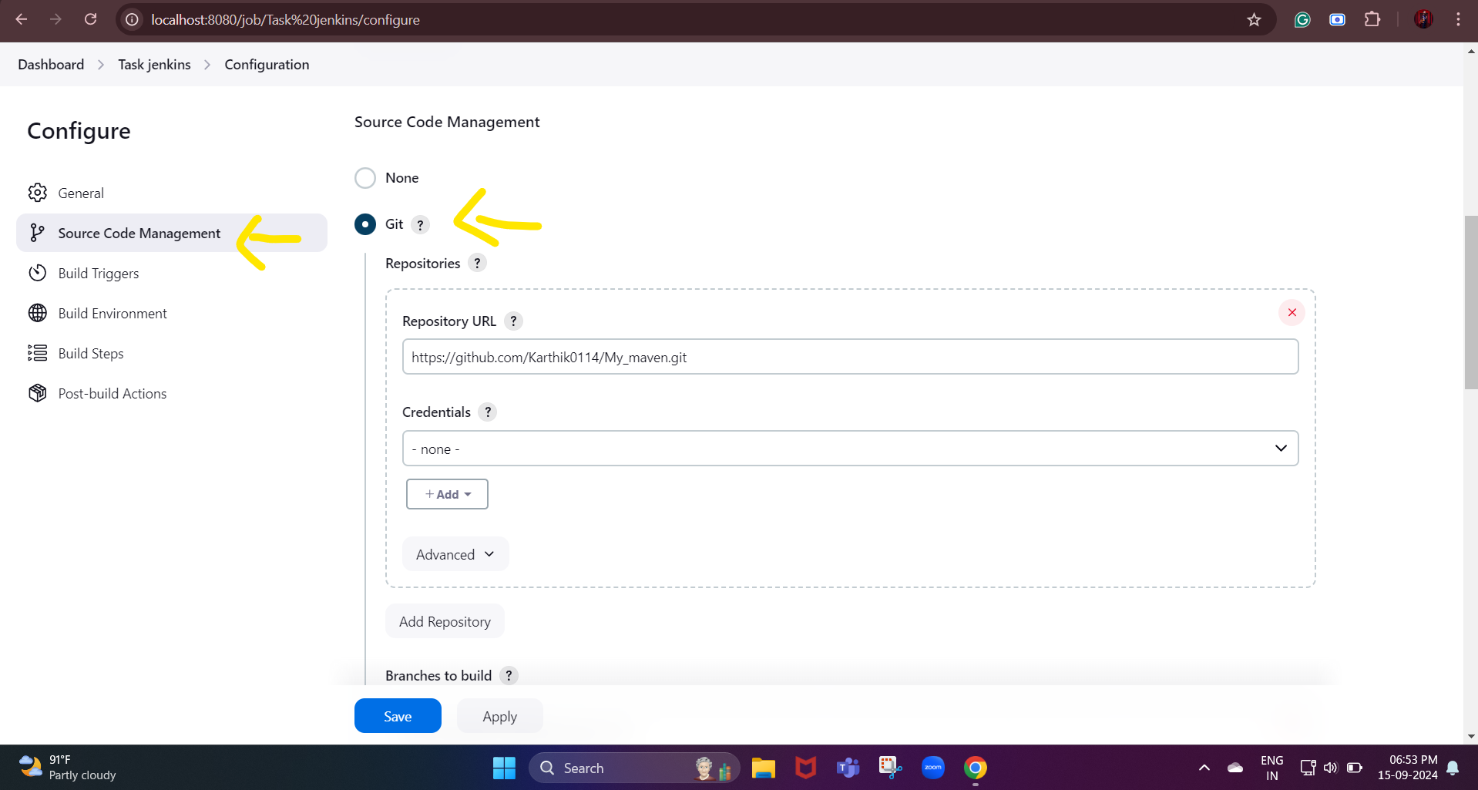

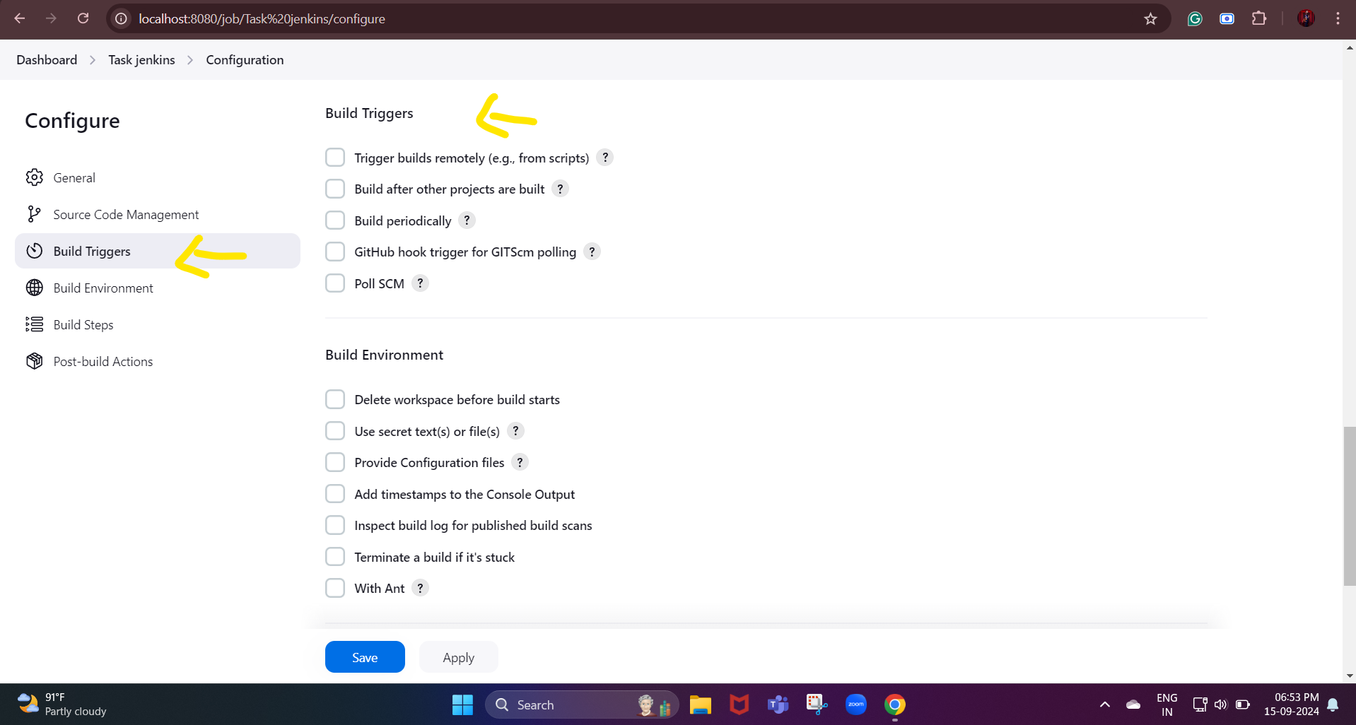

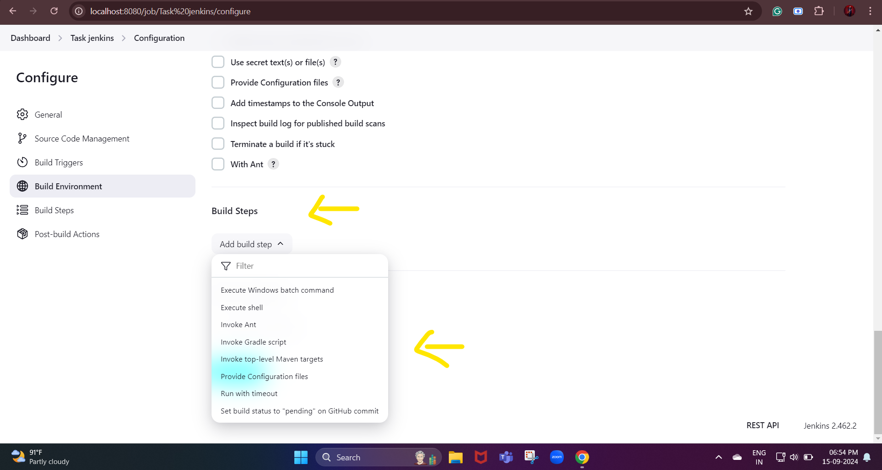

**Next, we are going to see how to create user**

**First, we need to go to manage Jenkins**

